DCC-GARCH correlation: NZDUSD and USDCHF
Method 09 / GARCH(1,1) + Engle DCC / Alpari D1 full available history

Study setup
Logical pair: NZDUSD , USDCHF
Broker symbols: NZDUSD_i , USDCHF_i
Snapshot: 2026-11-03_majors_alpari_D1
Timeframe: D1
Matched return window: 1999-01-05 to 2026-11-02 (UTC bar dates)
Matched return count n: 7185
Dropped unfinished last bar dated 2026-11-03 UTC after a tick-volume check against the prior complete day.
NZDUSD GARCH(1,1): mu=0.000013, omega=0.004878, alpha=0.040366, beta=0.950724
USDCHF GARCH(1,1): mu=-0.000342, omega=0.003457, alpha=0.040949, beta=0.956764
DCC: a=0.049086, b=0.926231, a+b=0.975317
Burn-in ignored in path summaries and chart: first 60 updates
Complete matched rows (Excel): NZDUSD-USDCHF_DCC_D1.xlsx
Complete matched rows (HTML table): NZDUSD-USDCHF_DCC_D1_data.html

Method carried forward
DCC-GARCH first fits a constant-mean GARCH(1,1) on each matched daily log return of close, ln(close_t / close_t-1), then updates Engle (2002) dynamic conditional correlation on the standardised shocks z = residual / conditional sigma. Quotes are not inverted. Correlation targeting sets Q_bar to the sample correlation of z; a and b are estimated by maximising the bivariate Gaussian DCC likelihood with a >= 0, b >= 0, and a + b < 1. Path summaries ignore the first 60 updates. The headline is rho on the last day. Same-sample Pearson r on log returns is a side check only. A high |rho| does not prove cause, lead-lag, or a trading signal.

Results
Latest DCC rho: -0.321299
Post-burn-in path (n=7125): mean=-0.423579, median=-0.442040, min=-0.745854, max=0.209908, std=0.148824
Share of post-burn-in days with |rho| >= 0.4: 61.53%; |rho| >= 0.7: 0.34%
Same-sample Pearson r: -0.393600
Latest rho minus r: 0.072301

Conclusion
Over 7185 matched daily log-return rows for NZDUSD and USDCHF (broker quote directions unchanged), latest DCC rho is -0.3213 (negative, weak conditional linear link in this sample) with fitted a=0.0491, b=0.9262 (a+b=0.9753). After a 60-day burn-in, path mean is -0.4236 and std is 0.1488. Same-sample Pearson r is -0.3936 (latest rho minus r = 0.0723). This does not establish cause, lead-lag, or a lasting trading rule.

Charts
Daily closes

Daily log returns
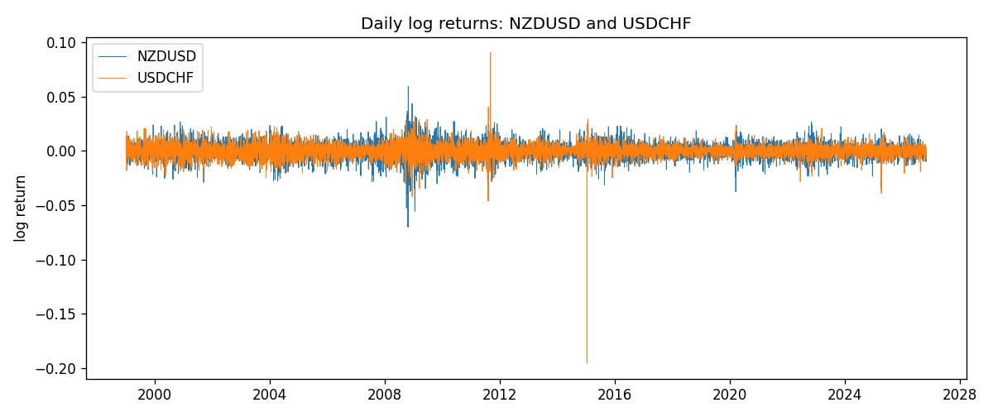
DCC rho path with Pearson r reference
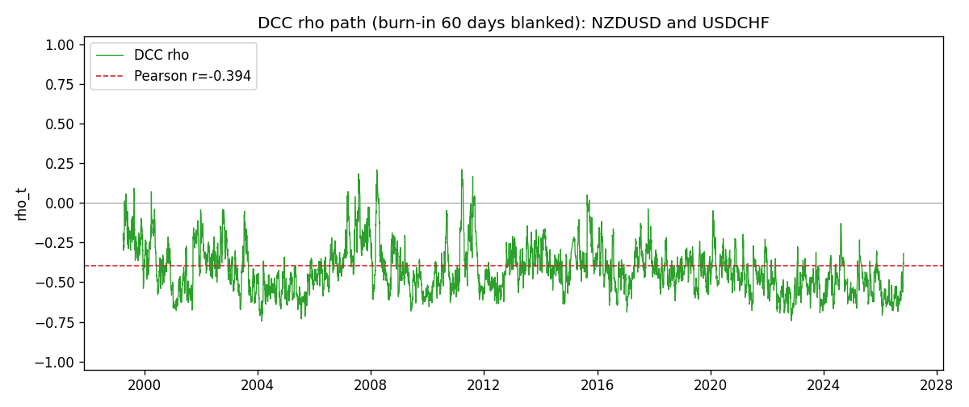

Data report
Every matched row that entered the DCC recursion is stored in the sibling Excel workbook named NZDUSD-USDCHF_DCC_D1.xlsx. Embedding all rows as a Word table is impractical at this length; the Word file holds the column list, column summaries, and the first and last 15 matched rows.
Columns: time, NZDUSD_open, USDCHF_open, NZDUSD_high, USDCHF_high, NZDUSD_low, USDCHF_low, NZDUSD_close, USDCHF_close, NZDUSD_tick_volume, USDCHF_tick_volume, NZDUSD_spread, USDCHF_spread, NZDUSD_real_volume, USDCHF_real_volume, NZDUSD_log_return, USDCHF_log_return, NZDUSD_sigma, USDCHF_sigma, NZDUSD_z, USDCHF_z, q11, q22, q12, rho_t
Column summaries (matched calculation rows)
column | count | mean | std | min | 25% | 50% | 75% | max
NZDUSD_open | 7185 | 0.65641395 | 0.10821881 | 0.3913 | 0.59137 | 0.6684 | 0.72499 | 0.88218
USDCHF_open | 7185 | 1.0976269 | 0.25248305 | 0.72022 | 0.92053 | 0.98988 | 1.2378 | 1.8219
NZDUSD_high | 7185 | 0.66033247 | 0.10871106 | 0.3961 | 0.59478 | 0.672 | 0.72937 | 0.88421
USDCHF_high | 7185 | 1.1029176 | 0.25422469 | 0.73305 | 0.92474 | 0.99353 | 1.2423 | 1.8313
NZDUSD_low | 7185 | 0.65272894 | 0.10781325 | 0.3897 | 0.58811 | 0.66417 | 0.72099 | 0.87988
USDCHF_low | 7185 | 1.0925083 | 0.25089773 | 0.08565 | 0.91719 | 0.98622 | 1.2317 | 1.8121
NZDUSD_close | 7185 | 0.65649284 | 0.10821292 | 0.3907 | 0.59165 | 0.6684 | 0.72502 | 0.8822
USDCHF_close | 7185 | 1.0976163 | 0.25237603 | 0.72025 | 0.92079 | 0.98995 | 1.2379 | 1.8217
NZDUSD_tick_volume | 7185 | 68718.644 | 123140.12 | 16 | 5587 | 33899 | 58511 | 1127682
USDCHF_tick_volume | 7185 | 74335.19 | 113494.16 | 18 | 12810 | 40241 | 70443 | 858589
NZDUSD_spread | 7185 | 30.278775 | 25.647496 | 0 | 9 | 17 | 40 | 80
USDCHF_spread | 7185 | 26.036326 | 24.697816 | 0 | 5 | 16 | 50 | 100
NZDUSD_real_volume | 7185 | 1.6703703e+10 | 8.4983725e+10 | 0 | 0 | 0 | 0 | 2.705649e+12
USDCHF_real_volume | 7185 | 2.3294091e+10 | 8.9133595e+10 | 0 | 0 | 0 | 0 | 1.9331921e+12
NZDUSD_log_return | 7185 | 2.019e-05 | 0.00763908 | -0.07027433 | -0.0042485 | 0.00023717 | 0.00458461 | 0.05966839
USDCHF_log_return | 7185 | -7.205e-05 | 0.00658891 | -0.19545699 | -0.0033516 | 8.095e-05 | 0.00331593 | 0.09051364
NZDUSD_sigma | 7185 | 0.00728249 | 0.00216648 | 0.00438979 | 0.00595062 | 0.00670058 | 0.00802988 | 0.02517264
USDCHF_sigma | 7185 | 0.00654569 | 0.00254562 | 0.00361855 | 0.00508474 | 0.00609474 | 0.00730665 | 0.03987387
NZDUSD_z | 7185 | -0.00220147 | 1.0000748 | -5.6253797 | -0.62968101 | 0.03192613 | 0.64759914 | 4.2270329
USDCHF_z | 7185 | 0.03933044 | 0.99909962 | -34.474716 | -0.48029327 | 0.07052851 | 0.59715194 | 6.7479863
q11 | 7185 | 1.0004384 | 0.22848758 | 0.61174629 | 0.85015012 | 0.95691761 | 1.0962181 | 2.9215566
q22 | 7185 | 1.0001171 | 1.819068 | 0.52105394 | 0.75674417 | 0.85923375 | 0.9861983 | 59.090693
q12 | 7185 | -0.40114916 | 0.19747992 | -3.7854227 | -0.50116485 | -0.38784632 | -0.29221677 | 0.30060171
rho_t | 7185 | -0.42109402 | 0.15091125 | -0.74585394 | -0.532212 | -0.44084003 | -0.33867557 | 0.20990771
First 15 matched rows (selected columns)
time | NZDUSD_log_return | USDCHF_log_return | NZDUSD_sigma | USDCHF_sigma | NZDUSD_z | USDCHF_z | q11 | q22 | q12 | rho_t
1999-01-05 | -0.0018597736 | 0.0039424743 | 0.0058906901 | 0.0083865918 | -0.31800335 | 0.51083375 | 1 | 1 | -0.40096749 | -0.40096749
1999-01-06 | 0.0020455609 | 0.013605652 | 0.0057982565 | 0.0082698953 | 0.35046317 | 1.6865186 | 0.95587776 | 0.96372295 | -0.38925943 | -0.40556631
1999-01-07 | 0.0062963171 | -0.0093883841 | 0.0057111823 | 0.0085875277 | 1.100093 | -1.0534702 | 0.91607547 | 1.0569308 | -0.3414282 | -0.34698482
1999-01-08 | -0.00055396548 | 0.011040268 | 0.0057525252 | 0.0086170891 | -0.098643813 | 1.3208576 | 0.93258466 | 1.0581207 | -0.3830251 | -0.38558088
1999-01-11 | 0.010290425 | 0.0052963193 | 0.005653469 | 0.0087575307 | 1.8178113 | 0.64378869 | 0.88894935 | 1.0903859 | -0.3710624 | -0.37689322
1999-01-12 | -0.0053157489 | -0.0098275602 | 0.0059277202 | 0.0086617378 | -0.8990361 | -1.0951475 | 1.0102574 | 1.0549765 | -0.2961417 | -0.28685482
1999-01-13 | -0.0099742238 | -0.018259701 | 0.0059195131 | 0.0087070223 | -1.6872518 | -2.0578816 | 1.0000893 | 1.0607061 | -0.23586361 | -0.2290045
1999-01-14 | -0.00018564931 | -0.0024256692 | 0.0061504862 | 0.0092750757 | -0.03237709 | -0.22468704 | 1.0907359 | 1.2150155 | -0.057926139 | -0.050318059
1999-01-15 | -0.00074294208 | 0.01794228 | 0.006037701 | 0.0091011574 | -0.12528405 | 2.0089708 | 1.0350077 | 1.1525459 | -0.063193054 | -0.057858671
1999-01-18 | -0.0018597736 | -0.0031856384 | 0.0059302967 | 0.0096584093 | -0.31587951 | -0.29445413 | 0.9841095 | 1.2903164 | -0.080783107 | -0.071688705
1999-01-19 | 0.0018597736 | -7.2518946e-05 | 0.0058365141 | 0.0094830618 | 0.31633404 | 0.028383338 | 0.9410934 | 1.2240697 | -0.080155364 | -0.074681521
1999-01-20 | 0.0040793678 | 0.0072259871 | 0.0057455811 | 0.009294565 | 0.70765379 | 0.81420346 | 0.90126468 | 1.1584936 | -0.083698805 | -0.08191176
1999-01-21 | 0.0040627941 | -0.0038232689 | 0.0057043945 | 0.0092382155 | 0.70985774 | -0.37686812 | 0.88404324 | 1.1302561 | -0.059139411 | -0.059163222
1999-01-22 | -0.012051689 | -0.0001445609 | 0.0056644806 | 0.0090827688 | -2.1299702 | 0.021702523 | 0.86824557 | 1.0785327 | -0.077805569 | -0.08040309
1999-01-25 | -0.0035504102 | 0.0024546976 | 0.0060719939 | 0.0089037696 | -0.58693994 | 0.3140667 | 1.0515715 | 1.0236764 | -0.084232121 | -0.081185222
Last 15 matched rows (selected columns)
time | NZDUSD_log_return | USDCHF_log_return | NZDUSD_sigma | USDCHF_sigma | NZDUSD_z | USDCHF_z | q11 | q22 | q12 | rho_t
2026-10-13 | 0.0047326165 | -0.0024955621 | 0.0049289417 | 0.0047774889 | 0.95743291 | -0.45083981 | 0.72008405 | 0.69458407 | -0.34868025 | -0.49303
2026-10-14 | -0.0037306483 | 0.0029388325 | 0.0049481394 | 0.0047300343 | -0.75667508 | 0.69354938 | 0.73664331 | 0.67800536 | -0.35404348 | -0.50096965
2026-10-15 | 0.0047634855 | -0.0097855323 | 0.0049326736 | 0.0047108672 | 0.96296661 | -2.0046951 | 0.73508945 | 0.67628352 | -0.36358308 | -0.51566679
2026-10-16 | 0.0057501001 | -0.0036230826 | 0.004952865 | 0.0050230029 | 1.1582417 | -0.6532751 | 0.75106341 | 0.84834524 | -0.44141751 | -0.55299976
2026-10-19 | 0.0018917133 | 0.0036351779 | 0.0050138089 | 0.0049926247 | 0.37461095 | 0.79654653 | 0.78619139 | 0.83139499 | -0.45589264 | -0.56389045
2026-10-20 | 0.0037199341 | -0.0026281224 | 0.0049527521 | 0.0049841651 | 0.74836142 | -0.45874132 | 0.7597662 | 0.82589122 | -0.41751184 | -0.52706889
2026-10-21 | 0.0030923331 | -0.00040027413 | 0.0049359248 | 0.0049323017 | 0.62376307 | -0.011879694 | 0.7558924 | 0.79997885 | -0.41346091 | -0.53169823
2026-10-22 | -0.0033035227 | -0.0048036381 | 0.0049023724 | 0.0048602058 | -0.67661286 | -0.91805952 | 0.74391238 | 0.76565507 | -0.39322107 | -0.52102589
2026-10-23 | 0.0030929853 | 0.005652514 | 0.0048765674 | 0.0048745507 | 0.63148922 | 1.2296916 | 0.73618955 | 0.77522785 | -0.34361969 | -0.45485036
2026-10-26 | -0.0028993932 | 0.0018407959 | 0.0048455829 | 0.0049548874 | -0.60114103 | 0.44046931 | 0.72613905 | 0.81694819 | -0.29005106 | -0.37658872
2026-10-27 | -0.00026399852 | 0.0026100526 | 0.004811754 | 0.004902057 | -0.057667964 | 0.60214161 | 0.71499375 | 0.79088903 | -0.29154858 | -0.38770557
2026-10-28 | -0.0097283914 | -0.0010142111 | 0.004743731 | 0.0048676135 | -2.0536318 | -0.13816447 | 0.68709559 | 0.77502626 | -0.28164288 | -0.38595084
2026-10-29 | 0.00062190714 | -0.0048680164 | 0.0050707836 | 0.0047993178 | 0.11998572 | -0.94312081 | 0.86810827 | 0.74347333 | -0.25683579 | -0.31969505
2026-10-30 | 0.00019537668 | 0.00071594559 | 0.0049948522 | 0.0048189439 | 0.036415721 | 0.21947246 | 0.82945837 | 0.75697199 | -0.25334099 | -0.31971887
2026-11-02 | -0.0025962955 | -0.0071459744 | 0.0049201935 | 0.0047549634 | -0.53042244 | -1.4309878 | 0.79301808 | 0.72817826 | -0.24415705 | -0.32129863

